Q 2 Which country in Europe had the highest fertility rate for its continent in 1980, but gradually changed to have the lowest fertility rate?

**Poland**

*In 1980: Poland had highest fertility rate:*

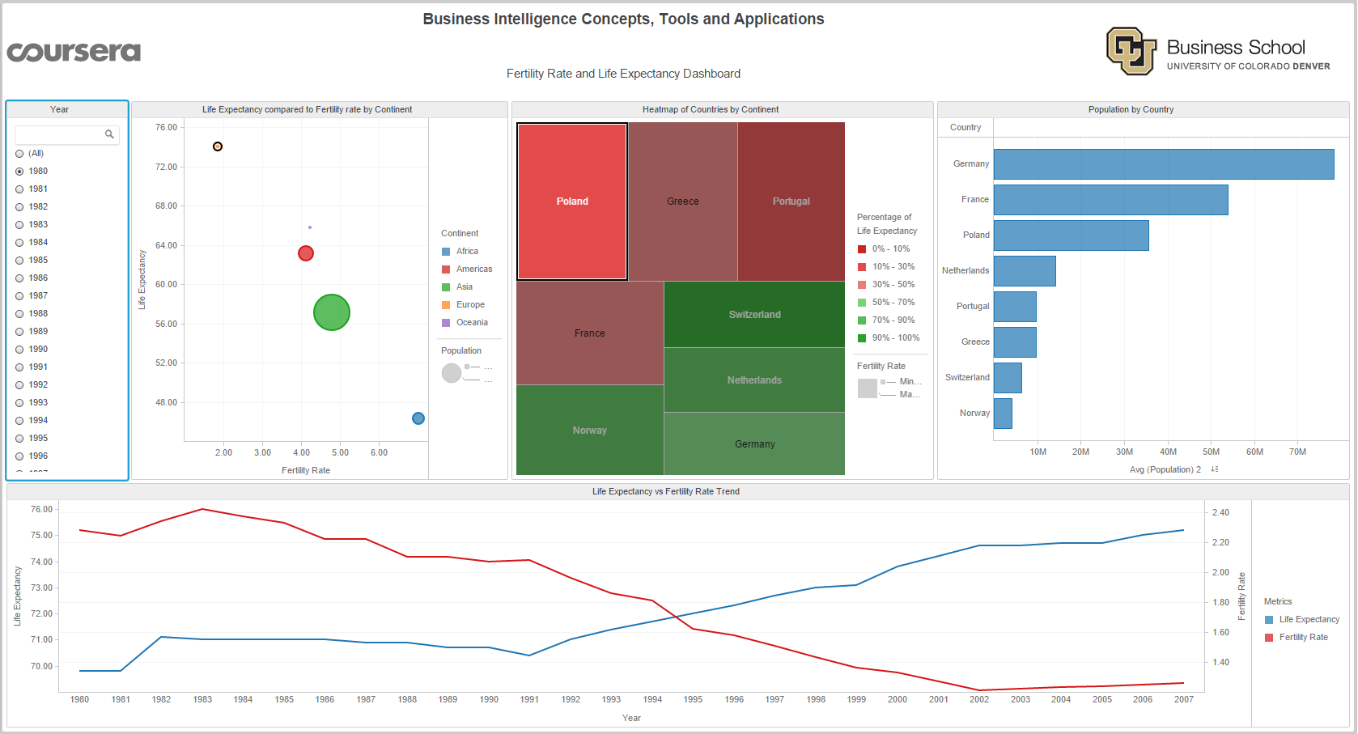

*In 2007: Poland has lowest fertility rate:*

